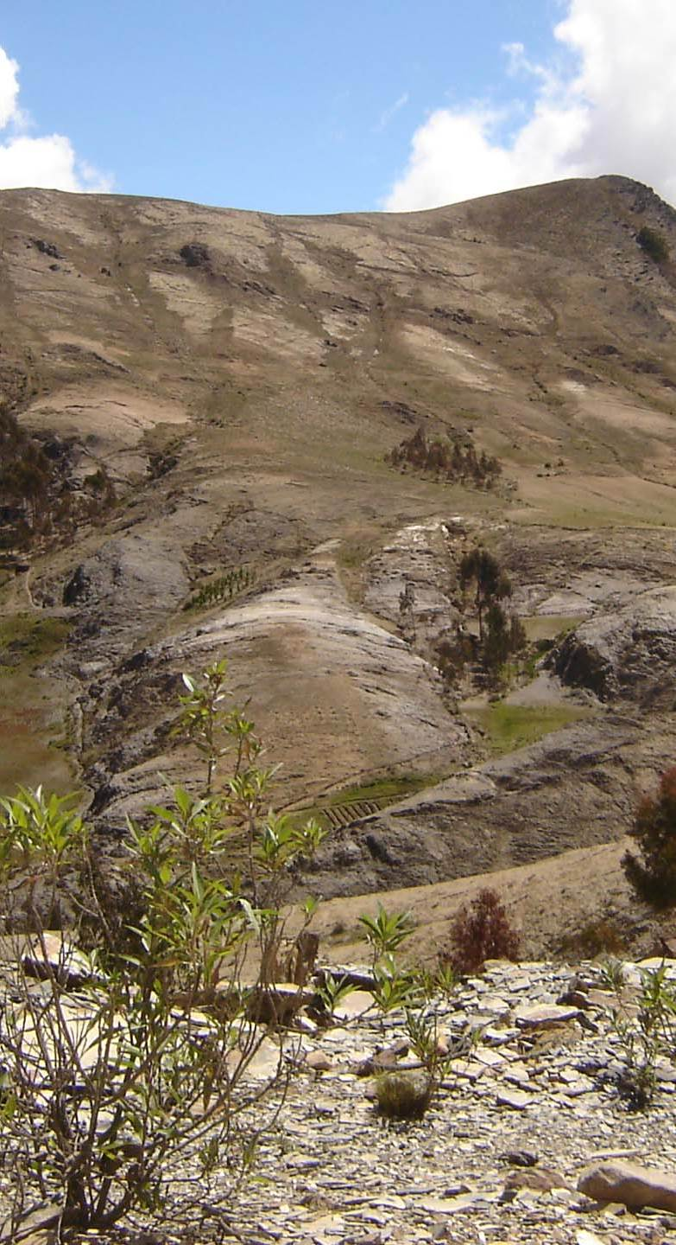
Annex 2
Environmental degradation and reclamation

This is a desert! Is it so hopeless because of the climate or the geology? For sure, nothing can be done here!

People living off whatever produces such a deteriorated landscape are extremely poor. They should just go! What can they do here? In fact, many will leave. Governmental and Non-Governmental organizations do what they can to alleviate the "social problem" that rural poverty poses. They distributed handouts to improve the "quality of life". When it’s Christmas, good people give plastic toys to the poor children of these areas.

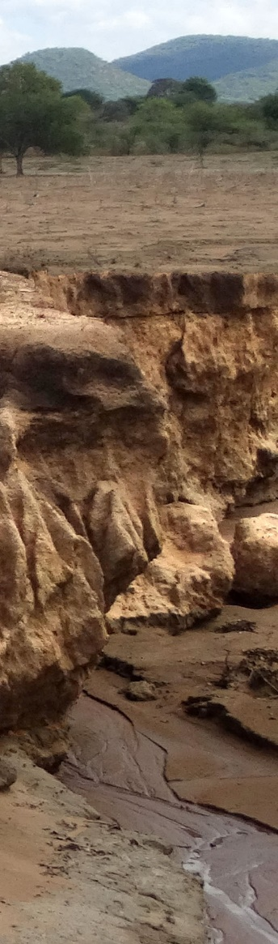
In this annex, we will explain the basics of environmental degradation and reclamation. Our interest in degradation originates from the fact that degradation is closely related to rural poverty, food insecurity and famine. More degradation means less plant production, and consequently -in a rural economy- poverty and hunger. Reclamation of degraded areas can reduce poverty and often has the potential to make rural Communities prosper.

Degradation, a physical phenomenon?
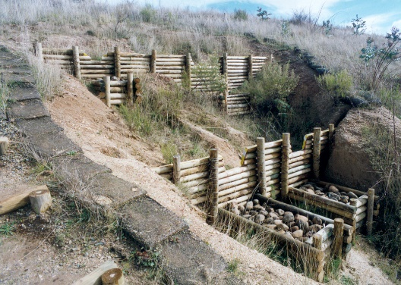
“Degradation” and “erosion” are often taken as synonyms. Erosion is easy to spot: soil was transported downhill, leaving behind very clear signs of what happened (see picture on the left). Erosion is a physical process: soil is on the move.

How can erosion be stopped? The answer seems obvious. Block that movement of soil and only let the water go downhill (see picture on the right).

Another option would be to allow the water to infiltrate by constructing infiltration ditches (picture on the right), or by building terraces or a combination of all such physical control measures.
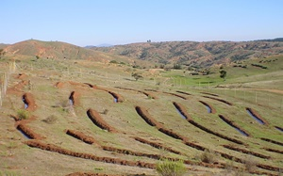
Erosion control measures are quite expensive and erosion usually affects the whole landscape. All those physical measures require regular maintenance which adds to the total cost of erosion control.

Building erosion control measures on the scale of a landscape requires enormous investments but such investments are hardly justified because these eroded lands are infertile and unproductive.

The population that depends for their livelihood on these unproductive resources is invariably extremely poor. They cannot be expected to invest in, or maintain, erosion control structures on any relevant scale. That’s why governments and charitable organizations often build such structures for them.

What can we do?
The Pachamama Raymi methodology is about peer learning and motivating people. It is into physical infrastructure. Maybe people can learn how to build erosion control structures. But those people are just too poor. So what can we do?
Eroded landscapes are hopeless…?
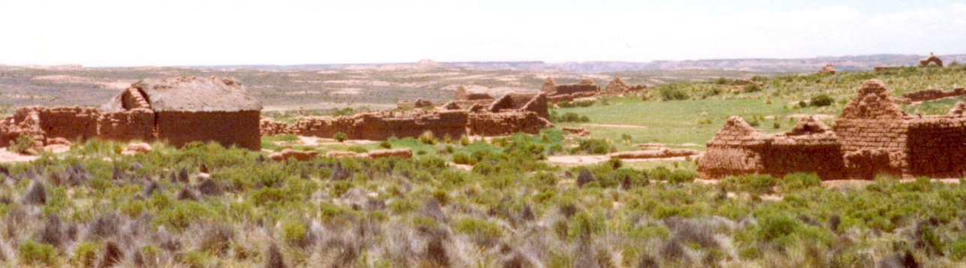
People abandon eroded landscapes.
Should we just assist them to move to a better place?

Erosion is not just a physical phenomenon. It is part of a much broader process in which people ultimately abandon their villages. We need to understand that broader process to come up with another perspective on erosion. Below we’ll see that there is one!

What started the process that resulted in erosion? Population pressure forced an increasingly more intensive exploitation of the land. Fallow periods are shortened resulting in unproductive and sterile land, in crop failures and also in erosion. Grass of lush pastures isn’t allowed enough time to regrow after grazing and great rangelands deteriorate.

Degradation of the main resources of rural areas –crop- and rangelands– is directly related to their overexploitation. The process of degradation can be described in ecological terms, using the concept of succession, which is a basic ecological phenomenon. Plant succession is the process of the development of vegetation where an area becomes successively occupied by different plant communities. We distinguish progressive and regressive succession.

Progressive succession is the process of the development of vegetation in which an area becomes successively populated by different plant communities of a higher ecological order. The last step in this sequence is the climax vegetation. This is the highest level of development of the plant community: the energy system (ecosystem) is at its highest point of productivity. The soil develops in parallel with its vegetative cover, culminating in a “climax soil” or mature soil. Erosion is virtually nonexistent in this soil and runoff is negligible and the soil is stable.

Regression –regressive succession– uses the same "ladder" as progressive succession, but in the opposite direction: the community of plants is being replaced by one of a lower ecological order. Productivity of the vegetation drops. The process culminates when productivity is (close to) zero. Causes of regression can be free grazing, excessive burning, plowing, cutting of trees and some other management practices. Erosion aggravates regression.

In grasslands, regression is characterized by the succession of plant species that are less palatable to livestock. That is, regression not only reduces the amount of fodder but also its quality. Under these conditions, livestock production drops and will approach zero as regression advances.

Regression shows up in soil development and is characterized by passing successively through the following stages:

- Loss of organic matter;
- Deterioration of soil structure and compaction;
- Accelerated erosion.

Erosion is the last step in the process of soil degradation and it ends when the rock is reached from which the soil was formed, thousands of years ago when progressive succession began. Obviously, erosion will simply continue when the “rock” is not solid but granular.

The loss of organic matter implies that soil fertility will drop. Increased soil exposure means that the difference between day and night temperatures increases. The loss of structure and compaction imply that infiltration capacity is reduced, which means that the moisture in the soil will decrease. In general, the micro-climate in and above the soil becomes increasingly hostile to the development of plants. Less water infiltrates in the compacted soil so springs will dry up and the base flow of rivers will reduce, often to zero.

In the Manyara region (Tanzania), regression is found on a very large scale; erosion is present everywhere. Erosion is the last step of the process of degradation (regression).

The most common type of erosion is "laminar erosion" also known as sheet erosion. This type of erosion is caused by rain, which almost homogeneously transports the soil towards gullies and rivers. There are no cuts or other clear signs that warn about its occurrence. That is why this type of erosion goes almost unnoticed. Over-exploitation of the land can accelerate this process and the topsoil –the fertile soil– will disappear within just a few years after erosion starts. The land will become infertile and unproductive.
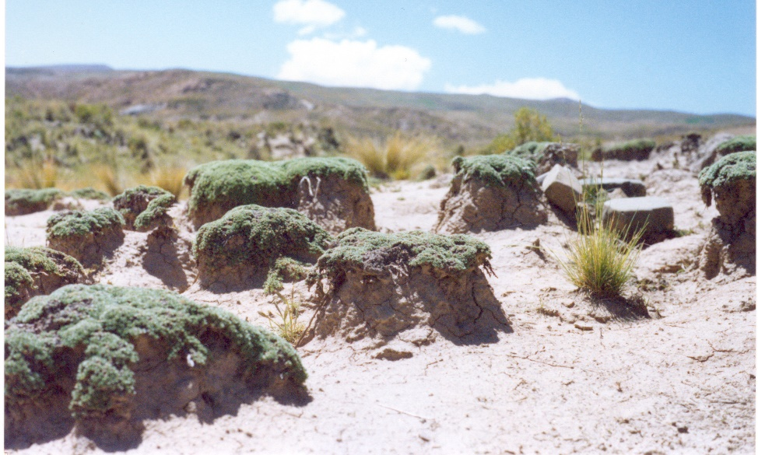
Laminar erosion. Raindrops mobilize unprotected soil.

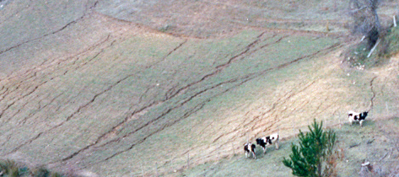
With worsening erosion, "laminar erosion" advances into furrow erosion. That is, erosion concentrates and furrows are formed by the eroding water. The furrows deepen and can become gullies.

A gully in Sarame (Manyara Region), a landmark of serious resource degradation.
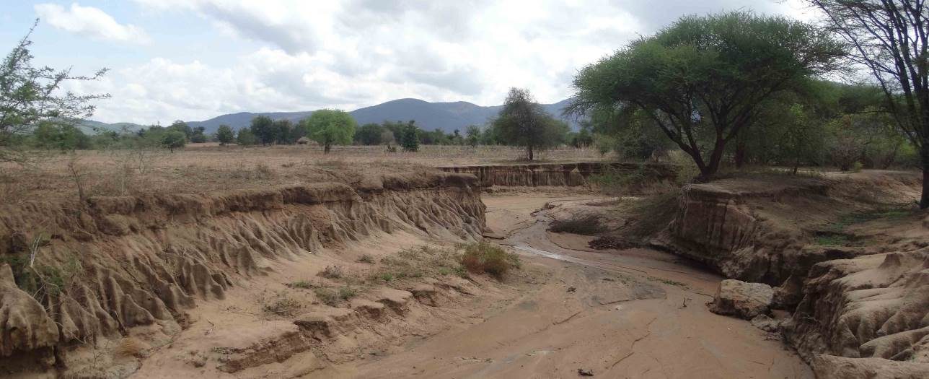
Sheet erosion is everywhere when gully erosion is present in the landscape.
Much of the rainwater disappears through such gullies instead of infiltrating to be taken up by plants or replenish fresh groundwater.

Erosion not only causes damage where it occurs. Sedimentation affects areas downstream of the eroded areas: rivers and lakes fill up with sediments.

Rivers overflow as less rainwater infiltrates into the soil and more rainwater quickly reaches the river as surface runoff. As a result, flooding becomes more frequent and flood peaks get higher, affecting agricultural land in the valleys. Inundated cropland and pastures are not only damaged by flooding but also by sediments. Sediments can cause excessive wear on turbines of hydro electrical plants.

Plant production in relation to degradation
Plant production and degradation are closely linked. Figure 6 shows this relation for graze lands (as an example). It illustrates that productivity declines due to deficient management. Productivity can be close to zero after years of poor management (bottom right hand corner of Figure 6).

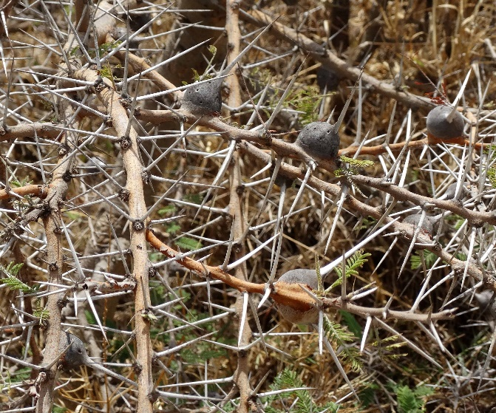 | After years of deficient management, there are no plant species left that animals can feed on…  Such species are too woody, too thorny, or venomous.

Figure 6
Condition of Pasture and Productivity
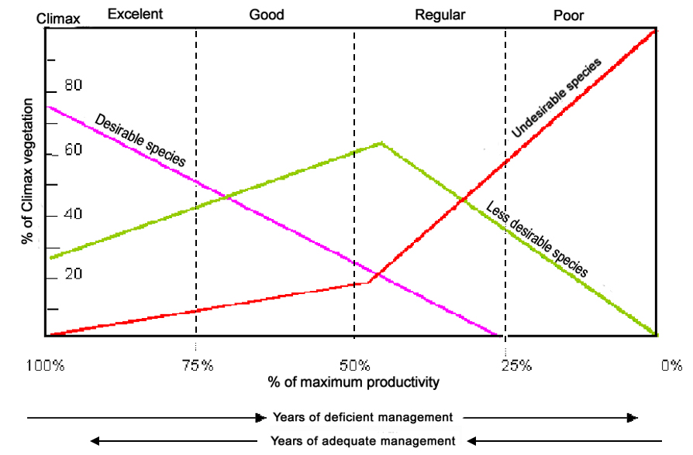

Figure 6 also illustrates the composition of rangelands as a function of management practices. After years of deficient management, there are no plant species left that animals can feed on. There are only “undesirable species”. Under such conditions, one animal needs many hectares and will spend all its energy to find something to eat.

Productivity and quality of management are linked as shown in Figure 6. It also shows that it is possible to boost productivity in severely degraded areas, simply by changing management practices. Importantly, the essence of changing management is not about making investments; it is about day-to-day decisions, such as where the animals should graze today, or which crop should come after peas. Such decisions depend on the farmer’s knowledge and know-how, and on what (s)he knows and understands of degradation and reclamation.

Improving management practices may also lower the costs and labour requirements, while production increases. Recurrent costs of external inputs are also likely to decrease (e.g. the need to acquire animal feed, fertilizers or medicine for sick and malnourished animals).

Projects and reclamation of resources
Some projects try to reclaim degraded resources by building terraces, infiltration ditches and building dams in gullies. These structures effectively stop erosion and surface runoff. Surface runoff and sedimentation in the river plain and lakes would be stopped if an entire degraded river basin were to be treated with such structures. Terraces and infiltration ditches and other erosion control structures are effective tools in fighting one symptom of the last step of the degradation process: erosion. However, such structures don’t stop the degradation process; it doesn’t stop the ecological process of regression. Even worse, stopping erosion with structures cannot reverse regression; structures cannot recover the potential productivity of the land.

It is sometimes argued that erosion control structures can achieve that water infiltrates in the soil and that this will help plant growth, which in turn will improve the soil, and thus result in soil reclamation. This would imply that areas which are absolutely flat, wouldn’t be affected by soil degradation. Unfortunately, that is not the case. Plant communities on flat areas will go through the very same regression as plant communities on slopes if exposed to deficient management: soil will lose organic matter and will lose its structure, become more compact and lose its fertility and most of its infiltration capacity. The only symptom of degradation that will be different in nature, is soil erosion. On slopes, soil will be transported downhill, while on absolutely flat areas, all forms of erosion are absent, except splash erosion.

The degradation process for flat and sloping areas, will follow the same route shown in Figure 6: toward zero productivity. The soil doesn’t become more fertile nor does it become more productive by constructing infiltration ditches or flat terraces. There is no point in fighting symptoms of degradation –such as erosion– when its cause (deficient management) is not addressed.

Reclamation of degraded soils –on slopes or flat areas– will take place if adequate management replaces deficient management. Reclamation of degraded soils means that:
- Soil will recover its structure and become less compact and more permeable for rainwater, so
- More rainwater will infiltrate and less water will be lost as surface runoff.
- The content of organic matter and soil fertility will increase.
- Soil cover will improve and that the quality of fodder and animal production will increase.
- Ultimately, erosion will diminish and disappear.

Changing management practices of many extremely poor farmers requires adoption of a number of innovations, by a majority, if it is to impact erosion of larger areas such as watersheds. Conventional training methodologies are not capable of such a feat within normal project duration (4 to 10 years).

Changing management practices from deficient to adequate by a majority of the population, is possible with the Pachamama Raymi methodology and it is very cost-effective; the results become evident within the first project years.

Changing management practices don’t just make poor people less poor, it can make them prosperous as productivity will go from almost zero to many times the present levels (see the x-axis of Figure 6). Incomes can be multiplied accordingly and increase 10 times and more as productivity was almost zero.

Extremely poor people living off severely degraded resources have great potential which can be unleashed simply by changing their management practices! That is what Pachamama Raymi did in several districts and many villages in Peru and now proposes for the Manyara Region (Tanzania).

